Department of Computer Science and Engineering

Assignment Questions

Course Code & Name: CSA0615 –Design and Analysis of Algorithms
Particular | Details
Department: | AI&DS
Programme: | B.Tech
Course Code & Course Name | CSA0621 - Design and Analysis of Algorithms
Academic Year / Batch | 2026-2027
Faculty Name | Dr G Nagarajan
Assignment Title | Development of an Efficient Algorithmic Solution for Large-Scale Data Processing
Date of Issue | 02-09-26
Date of Submission | 03-09-26
Maximum Marks | 100
Course Outcome(s) – CO | CO1: Analyse the efficiency of recursive and non-recursive algorithms using asymptotic notations (Big-O, Ω, Θ) and complexity-analysis methods such as the master theorem, substitution, and iteration.  CO2: Apply brute-force techniques such as sorting and searching to solve computational problems.  CO3: Apply divide-and-conquer techniques to design efficient algorithmic solutions.
Bloom's Taxonomy Level | L4 – Analyse; L5 – Evaluate; L6 – Create
SDG Mapping (SDG 1-17) | SDG 9 – Industry, Innovation and Infrastructure
Industry / Societal Relevance | Smart Infrastructure Planning and Geospatial Data Optimization

Assignment Problem / Challenge
An infrastructure-planning agency manages a large collection of geographical location data, such as airports, cell towers, or weather stations. Each location is represented using its coordinates.
The main problem is to find the two locations that are closest to each other. Finding these locations is useful for identifying facilities that are unnecessarily close, detecting possible safety problems, and improving service coverage.
Three different approaches will be developed and compared:
- Brute-Force Algorithm – checks every possible pair of points and finds the minimum distance. Its time complexity is O(n²).
- Divide-and-Conquer Algorithm – divides the points according to their x-coordinate, solves smaller problems recursively, and checks points near the dividing boundary. Its time complexity is O(n log n).
- Hybrid Algorithm – uses divide-and-conquer for large problems but switches to brute force when the number of points in a smaller subproblem becomes sufficiently small.

Problem Statement
An infrastructure-planning agency maintains a large, publicly available geospatial dataset of facility locations — for example, the OpenFlights airports dataset (~40,000 points) or a cell-tower / weather-station dataset containing 10⁴–10⁶ coordinate records. To detect redundant or dangerously close facilities and to optimise service coverage, the agency must identify the closest pair of locations — the two points separated by the minimum Euclidean distance in the dataset. Develop, implement, and evaluate a solution to this Closest-Pair-of-Points problem. Implement (i) a Brute-Force algorithm that evaluates all n(n−1)/2 pairs, of order O(n²), and (ii) a Divide-and-Conquer algorithm that recursively partitions the point set about the median x-coordinate and merges across the dividing strip, of order O(n log n) ; then develop an optimised hybrid that reverts to brute force below a threshold sub-problem size. Analyse the theoretical efficiency of each approach using Big-O, Ω, and Θ notations, solving the recurrence T(n) = 2T(n/2) + O(n) by the master theorem. Experimentally evaluate all three algorithms on the chosen dataset across increasing input sizes (for example, 10³ to 10⁶ points), measuring execution time, number of distance computations/comparisons, memory utilisation, and scalability. Based on the theoretical and experimental results, optimise the solution and justify why the proposed hybrid is most suitable for large-scale infrastructure data — reflecting Bloom’s Levels 4–6 (Analyse, Evaluate, Create) and contributing to SDG 9 (Industry, Innovation and Infrastructure).

Requirements and Constraints
The project requires the use of a publicly available real-world coordinate dataset containing enough records to test different input sizes, ranging from 10³ to 10⁶ points.
The following requirements and constraints must be followed:
- Dataset Requirement:
A real-world geographical dataset containing coordinate records must be used.
- Input Sizes:
The dataset should support testing with different numbers of points, from approximately 1,000 to 1,000,000 points.
- Algorithms:
All three algorithms must be implemented:
  - Brute Force
  - Divide and Conquer
  - Hybrid Algorithm
- Same Environment:
All algorithms must be executed on the same computer and computational environment to ensure a fair comparison.
- Identical Inputs:
Each algorithm must be tested using the same input points for every input size.
- Performance Measurement:
The experiment must record:
  - Execution time
  - Number of distance calculations
  - Number of comparisons
  - Memory usage
  - Scalability
- Hybrid Threshold:
The threshold at which the hybrid algorithm changes from divide-and-conquer to brute force must be clearly specified and justified.
- Assumptions:
All assumptions made during dataset preparation, distance calculation, and algorithm implementation must be clearly documented.
- Limitations:
Limitations such as hardware capacity, memory requirements, dataset size, and execution time must also be explained.

Student Work

Problem Statement and Problem Formulation

The problem is to identify the closest pair of locations from a large set of geographical coordinate points. The dataset may contain locations such as airports, cell towers, or weather stations.

For a set of n coordinate points, the objective is to find the two points having the minimum Euclidean distance between them.

The problem can be formulated as follows:

Input: A set of n points represented by their coordinates (x, y).

Output: The two points that have the smallest distance between them.

Distance: The Euclidean distance between two points is calculated and compared.

Goal: Find the minimum distance efficiently.

Three algorithms will be developed to solve the problem:

Brute-Force Algorithm: Compares every possible pair of points. Its time complexity is O(n²).

Divide-and-Conquer Algorithm: Divides the points based on the median x-coordinate and combines the results by checking points near the dividing region. Its time complexity is O(n log n).

Hybrid Algorithm: Uses divide-and-conquer for large subproblems and changes to brute force when the number of points becomes smaller than a selected threshold.

Objective and Expected Outcomes

Objective

The main objective of this project is to develop and compare different algorithms for solving the Closest-Pair-of-Points problem using a large real-world coordinate dataset.

The specific objectives are:

To implement the Brute-Force algorithm for finding the closest pair of points.

To implement the Divide-and-Conquer algorithm to improve processing efficiency.

To develop a Hybrid algorithm that combines divide-and-conquer with brute force for small subproblems.

To analyse the time complexity of the three algorithms using Big-O, Ω, and Θ notations.

To measure execution time, distance calculations, comparisons, memory usage, and scalability.

To determine a suitable threshold for the hybrid algorithm.

To identify the most efficient approach for processing large-scale infrastructure data.

Expected Outcomes

After completing the project, the following outcomes are expected:

The closest pair of locations should be correctly identified by all three algorithms.

The Brute-Force algorithm is expected to become slower as the dataset size increases because of its O(n²) complexity.

The Divide-and-Conquer algorithm is expected to provide better performance with O(n log n) complexity.

The Hybrid algorithm is expected to reduce unnecessary recursive operations for small subproblems.

Experimental results should clearly show the performance differences between the three approaches.

The best algorithm should be selected based on both theoretical analysis and experimental results.

The final solution should be suitable for large-scale geospatial and infrastructure-planning applications.

Requirements, Constraints and Assumptions.

Requirements

Use a publicly available real-world coordinate dataset.

The dataset should contain enough records for different input sizes from 10³ to 10⁶ points.

Implement three algorithms:

Brute Force

Divide and Conquer

Hybrid

Run all three algorithms in the same computational environment.

Use identical input data for a fair comparison.

Measure execution time and operation counts.

Record the number of distance calculations and comparisons.

Select and document an appropriate threshold for the hybrid algorithm.

Constraints

Very large datasets may require high memory and processing power.

The brute-force method may take a long time for large input sizes.

All experiments should be performed under similar system conditions.

The available dataset may limit the maximum number of points that can be tested.

Assumptions

Each location is represented using an (x, y) coordinate.

The coordinates are valid and correctly formatted.

Euclidean distance is used to calculate the distance between points.

The same dataset is provided to all three algorithms.

The hybrid algorithm uses brute force when the subproblem size reaches the selected threshold.

The assignment requires the assumptions, limitations, threshold, timings, and operation counts to be clearly documented.

Application of Relevant Course Knowledge

This project applies important concepts from the Design and Analysis of Algorithms course, especially Brute Force, Divide and Conquer, recursion, asymptotic analysis, and the Master Theorem.

Brute-Force Technique

The brute-force algorithm checks every possible pair of points and calculates their distance.

For n points, the number of pairs is:

n(n − 1) / 2

Therefore, its time complexity is:

O(n²)

This approach is simple and useful for small datasets, but its performance decreases significantly as the number of points increases.

Divide-and-Conquer Technique

The divide-and-conquer method divides the dataset into two parts using the median x-coordinate. Each part is solved recursively, and the results are combined by checking points near the dividing line.

The recurrence is:

T(n) = 2T(n/2) + O(n)

Using the Master Theorem, the resulting complexity is:

Θ(n log n)

Therefore, divide-and-conquer is more suitable for large datasets than brute force.

Hybrid Technique

The hybrid approach combines both techniques. It uses divide-and-conquer when the problem is large and changes to brute force when the subproblem becomes smaller than a selected threshold.

This reduces recursion overhead while maintaining approximately O(n log n) overall performance.

The course assignment specifically requires applying brute-force and divide-and-conquer techniques and analysing their efficiency using asymptotic notations.

Proposed Solution
The proposed solution consists of three stages: data preparation, algorithm implementation, and performance evaluation.
Step 1: Collect the Dataset
A publicly available geographical dataset containing coordinate information is selected.
Examples include:
- Airport locations
- Cell towers
- Weather stations
Step 2: Prepare the Data
The required coordinate values are extracted from the dataset and converted into a suitable format such as:
(x, y)
Different input sizes are created for testing.
Step 3: Implement Brute Force
The algorithm checks every possible pair of points.
Process:
- Select the first point.
- Compare it with every remaining point.
- Calculate the distance.
- Store the smallest distance.
- Repeat until all pairs are checked.
Step 4: Implement Divide and Conquer
The points are first arranged according to their x-coordinate.
Process:
- Find the median x-coordinate.
- Divide the points into left and right sets.
- Recursively find the closest pair in each set.
- Select the smaller of the two distances.
- Create a strip around the dividing line.
- Check relevant points within the strip.
- Return the overall closest pair.
Step 5: Develop the Hybrid Algorithm
The hybrid algorithm improves the divide-and-conquer approach.
Process:
- Start with the complete dataset.
- Divide the points recursively.
- If the subproblem contains more points than the threshold, continue dividing.
- If the subproblem is smaller than or equal to the threshold, use brute force.
- Combine the results from the smaller subproblems.
- Return the closest pair.
Step 6: Performance Testing
Each algorithm is tested using the same input sizes and environment.
The following values are recorded:
Measurement | Purpose
Execution Time | Measures practical speed
Distance Calculations | Measures computational work
Comparisons | Measures number of pair checks
Memory Usage | Measures resource requirements
Input Size | Measures scalability
Step 7: Select the Best Solution
- The results of all three algorithms are compared. The hybrid threshold is adjusted and tested to determine a suitable value.
- Finally, the algorithm with the best balance of speed, scalability, memory usage, and correctness is selected for large-scale infrastructure data.
- This methodology follows the assignment requirement to design, compare, optimize, test, and justify an algorithmic solution.

Pseudocode /Algorithm

The Closest-Pair-of-Points problem is solved using three different algorithms: Brute Force, Divide and Conquer, and Hybrid Algorithm.

Brute-Force Algorithm:

First, the algorithm takes all the coordinate points as input. It compares every point with every other point and calculates the distance between each pair. The smallest distance found during the comparison is stored as the minimum distance, along with the two corresponding points. After all possible pairs are checked, the algorithm returns the closest pair. Since every possible pair is examined, the time complexity of this method is O(n²).

Divide-and-Conquer Algorithm:

In this method, the points are first arranged according to their x-coordinates. The complete set of points is then divided into two smaller sets using the middle x-coordinate. The algorithm recursively finds the closest pair in the left and right sections. The smaller of these two distances is selected. Next, a narrow strip around the dividing line is created, and the relevant points inside the strip are compared to check whether a closer pair exists across the two sections. Finally, the smallest distance obtained from the left section, right section, and middle strip is returned. The time complexity of this method is O(n log n).

Hybrid Algorithm:

The hybrid approach combines the advantages of both algorithms. It uses the divide-and-conquer method when the number of points is large. When a subproblem becomes smaller than a predefined threshold, the algorithm switches to the brute-force method instead of continuing the recursive division. This reduces unnecessary recursion and can improve practical execution time. The hybrid algorithm maintains approximately O(n log n) time complexity while providing better performance for small subproblems.

Source Code and Environment / Tools Used

k Programming Language: Python

Dataset: Publicly available geographical coordinate dataset

Algorithms Implemented:

Brute-Force Algorithm

Divide-and-Conquer Algorithm

Hybrid Algorithm

Pandas: Used for loading and managing the dataset.

NumPy: Used for numerical and distance calculations.

Matplotlib: Used to create performance graphs.

Time Module: Used to measure execution time.

Memory Monitoring: Used to observe memory utilisation.

Development Environment: Jupyter Notebook / Google Colab / VS Code

Testing: All three algorithms are tested using the same input data and computational environment.

Performance Measures:

Execution time

Distance calculations

Number of comparisons

Memory usage

Scalability

Hybrid Threshold: A fixed threshold is selected for switching from divide-and-conquer to brute force.

Result Analysis: Performance results are compared using tables and graphs.

Test Cases and Expected Results

The project should test all three algorithms using different input sizes. Each test case should use the same set of points for all three algorithms so that the results can be compared fairly.

Test Case 1 – Small Dataset:

Input Size: 1,000 points

Algorithms: Brute Force, Divide and Conquer, Hybrid

Expected Result: All three algorithms should identify the same closest pair.

Expected Observation: Brute Force should complete quickly because the input size is small.

Test Case 2 – Medium Dataset:

Input Size: 5,000 points

Algorithms: Brute Force, Divide and Conquer, Hybrid

Expected Result: All algorithms should produce the same minimum distance.

Expected Observation: Divide and Conquer and Hybrid should require fewer distance calculations than Brute Force.

Test Case 3 – Larger Dataset:

Input Size: 10,000 points

Algorithms: Brute Force, Divide and Conquer, Hybrid

Expected Result: The closest pair should be correctly identified.

Expected Observation: The execution time of Brute Force should increase more rapidly.

Execution Screenshots

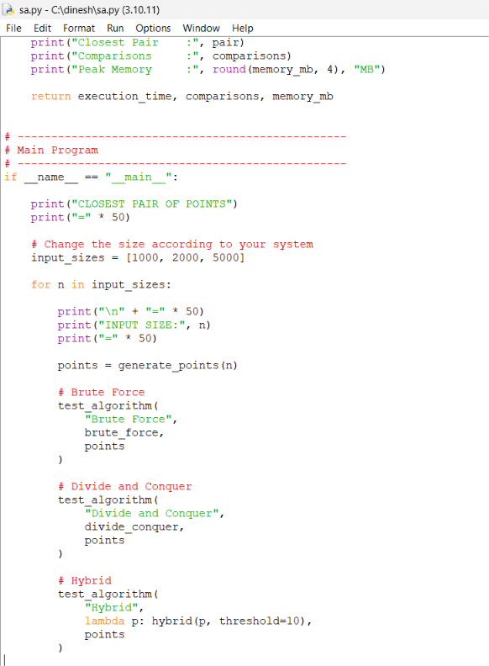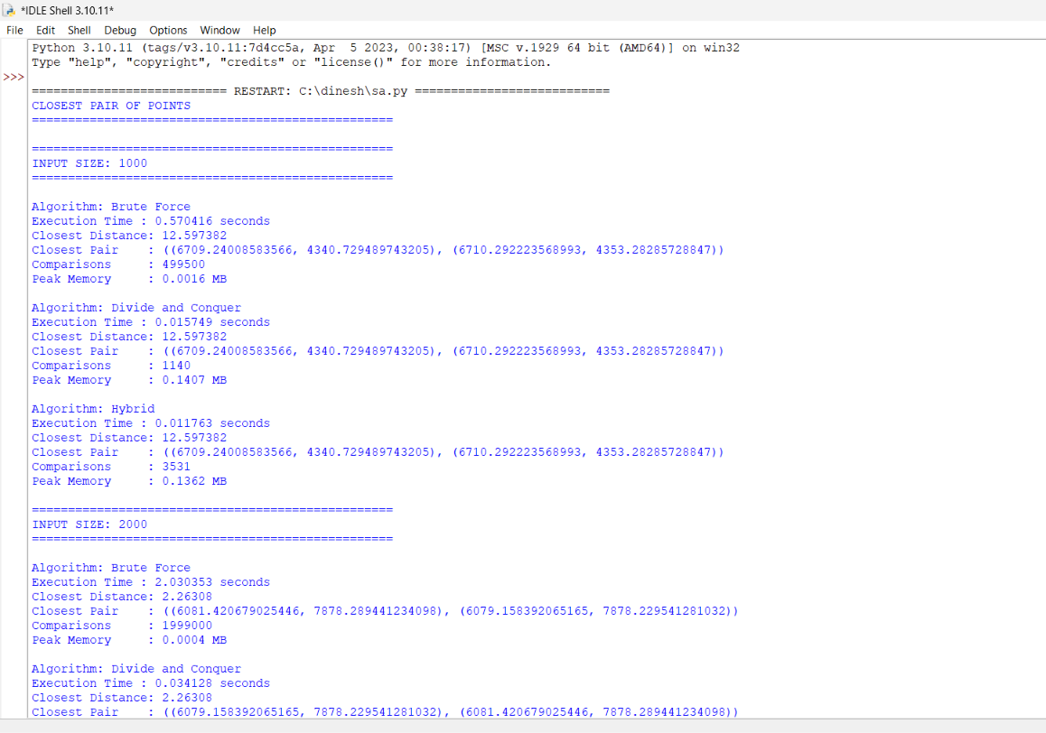

Results and Validation – appropriate tables, graphs, performance metrics, experimental observations, or other evidence, wherever applicable

The results of the three algorithms will be compared using different input sizes. The same dataset and computational environment will be used for all algorithms.

Performance Comparison Table
Input Size | Brute Force Time | Divide and Conquer Time | Hybrid Time | Brute Force Comparisons | D&C Comparisons | Hybrid Comparisons
1,000 | Record | Record | Record | Record | Record | Record
5,000 | Record | Record | Record | Record | Record | Record
10,000 | Record | Record | Record | Record | Record | Record
50,000 | Record | Record | Record | Record | Record | Record
100,000 | Record | Record | Record | Record | Record | Record
500,000 | Record | Record | Record | Record | Record | Record
1,000,000 | Record | Record | Record | Record | Record | Record

Performance Metrics

Execution Time: Time taken by each algorithm to find the closest pair.

Distance Calculations: Total number of distances calculated.

Comparisons: Number of point pairs compared.

Memory Usage: Memory required during execution.

Scalability: Performance when the number of input points increases.

Minimum Distance: Closest distance obtained from each algorithm.

Correctness: Results from all three algorithms are compared to ensure they identify the same closest pair.

Graphs to Include

Graph 1: Input Size vs Execution Time

Graph 2: Input Size vs Number of Comparisons

Graph 3: Input Size vs Memory Usage

Graph 4: Algorithm vs Execution Time for selected input sizes

Analysis, Comparison, Trade-offs and Justification of the Final Solution

Brute Force Algorithm

Checks the distance between every pair of points.

Time complexity is O(n²).

Simple to implement and suitable for small datasets.

Becomes slow when the number of points increases.

Divide and Conquer Algorithm

Divides the coordinate points into smaller groups.

Finds the closest pair in each group and combines the results.

Time complexity is O(n log n).

Performs better than brute force for large datasets.

Hybrid Algorithm

Combines Divide and Conquer with Brute Force.

Uses Divide and Conquer for large datasets.

Switches to Brute Force when the number of points becomes smaller than the selected threshold.

Reduces unnecessary recursive operations for small groups.

Broader Considerations / SDG Relevance, wherever applicable

- Real-World Application
  - The proposed solution can be used for analysing large-scale geographical coordinate data.
  - It can support applications such as cell tower placement, weather station analysis, transportation planning, and infrastructure development.
- Scalability
  - The solution is designed to handle datasets ranging from thousands to millions of coordinate points.
  - The Hybrid approach improves performance when processing large datasets.
- Efficient Resource Usage
  - Reducing unnecessary distance calculations can save processing time.
  - Better algorithm efficiency is useful when handling large amounts of real-world data.
- Accuracy and Reliability
  - The algorithms identify the closest pair of coordinates accurately.
  - Comparing the results of different approaches helps validate the correctness of the solution.
- SDG 9 – Industry, Innovation and Infrastructure
  - This project is related to SDG 9: Industry, Innovation and Infrastructure.
  - Efficient algorithms can support smarter infrastructure planning and better use of geospatial data.
  - The project demonstrates how algorithmic optimisation can contribute to technology-driven infrastructure solutions.
- Future Impact
  - The approach can be extended to larger datasets and other geographic optimisation problems.
  - It can contribute to developing faster and more efficient data-processing systems for modern infrastructure applications.

Conclusion, Limitations and Possible Improvements

Conclusion

The project successfully compares three approaches for finding the closest pair of points.

Brute Force is easy to understand but becomes inefficient for large datasets.

Divide and Conquer provides better performance with O(n log n) time complexity.

The Hybrid approach combines both methods and is suitable for large-scale coordinate data.

Overall, the Hybrid algorithm provides a practical balance between performance, simplicity, and scalability.

Limitations

Brute Force becomes very slow as the dataset size increases.

The Divide and Conquer method is more complex to implement.

The Hybrid algorithm depends on selecting a suitable threshold.

Execution time may vary depending on the computer system and available memory.

Very large datasets may require significant memory and processing resources.

Possible Improvements

Experiment with different threshold values to identify the best Hybrid performance.

Use larger and more diverse real-world datasets for testing.

Improve memory management for very large coordinate datasets.

Use parallel or distributed processing for extremely large datasets.

Extend the algorithm to support additional geospatial optimisation problems.

Compare the proposed methods with other advanced closest-pair techniques.

Individual Contribution of Group Members
- P. Divakaran – 192424260
  - Worked on understanding and formulating the problem statement.
  - Contributed to the design of the Brute Force algorithm.
  - Helped analyse the time complexity using Big-O, Ω, and Θ.
  - Assisted in testing the algorithm with different input sizes.
- C. MohammedUbed – 192525115
  - Contributed to the design and implementation of the Divide and Conquer algorithm.
  - Worked on analysing the O(n log n) time complexity.
  - Assisted with performance comparison between the algorithms.
  - Contributed to documenting the experimental results.
- U. Vishnu Mohan Reddy – 192425107
  - Contributed to the development of the Hybrid algorithm.
  - Worked on selecting and analysing the threshold for switching between algorithms.
  - Assisted in measuring execution time, comparisons, and memory usage.
  - Contributed to the final analysis, conclusions, and documentation.

References, including datasets, software/tools and other sources used, wherever applicable

Course Material

CSA0615 – Design and Analysis of Algorithms course materials.

Topics used: Brute Force, Divide and Conquer, Asymptotic Analysis, Big-O, Ω, Θ, and Master Theorem.

Dataset

Publicly available geospatial coordinate dataset used for testing the closest-pair problem.

Dataset examples include OpenFlights airport coordinates or similar public coordinate datasets.

Programming Language

Python was used for implementing and testing the algorithms.

Software and Libraries

Jupyter Notebook / Google Colab / VS Code for development and execution.

NumPy for numerical operations.

Pandas for data handling.

Matplotlib for generating performance graphs.

Python Time Module for measuring execution time.

Algorithmic References

Standard Design and Analysis of Algorithms concepts were used to develop:

Brute Force approach

Divide and Conquer approach

Hybrid approach

Complexity analysis using the Master Theorem

Project Documentation

Experimental observations, execution results, performance comparisons, and analysis were used to validate the final Hybrid solution.

One-Page Individual Reflection

- Learning Experience
  - Through this project, I gained a better understanding of how algorithms can be applied to solve real-world problems involving large datasets.
  - I learned how to find the closest pair of geographical coordinates using different algorithmic approaches.
- Understanding of Algorithms
  - I understood the working of the Brute Force method and its O(n²) time complexity.
  - I learned how the Divide and Conquer technique improves efficiency with O(n log n) complexity.
  - I also understood how a Hybrid Algorithm can combine both approaches to improve practical performance.
- Practical Implementation
  - Implementing the algorithms in Python helped me connect theoretical concepts with practical programming.
  - I learned how to measure execution time, comparisons, and memory usage.
  - Testing different input sizes helped me understand how algorithm performance changes as the dataset grows.
- Problem-Solving Skills
  - The project improved my ability to analyse a problem before selecting an appropriate algorithm.
  - I learned that an algorithm that works well for a small input may not be suitable for a large dataset.
  - Comparing different approaches helped me understand the importance of efficiency and scalability.
- Teamwork
  - Working as a group helped me divide the project into different tasks and complete the work effectively.
  - Discussing algorithm design, implementation, testing, and results with team members improved my communication and collaboration skills.
- Real-World Relevance
  - The project showed me how algorithm optimisation can be useful in applications such as geospatial data processing and infrastructure planning.
  - It also helped me understand the connection between efficient computing and SDG 9 – Industry, Innovation and Infrastructure.
- Challenges Faced
  - Handling large input sizes was challenging, especially for the Brute Force algorithm.
  - Selecting an appropriate threshold for the Hybrid algorithm required careful consideration.
  - Measuring and comparing performance also required using the same input and computing environment.
- Overall Reflection
  - Overall, this project improved my knowledge of algorithm design, complexity analysis, programming, and performance evaluation.
  - It helped me understand that choosing an efficient algorithm is important when working with large-scale data.
  - I believe the experience gained from this project will help me design more efficient solutions for future technical problems.

Assessment Rubric

Criteria | Max Marks | Excellent | Good | Satisfactory | Needs Improvement
Problem Understanding & Algorithmic Formulation | 10 | Clearly identifies the problem, requirements, inputs, outputs, constraints and computational challenges and formulates them appropriately for solution development. | Problem and major requirements are correctly formulated with minor gaps. | Basic formulation is provided, but requirements or constraints are partially identified. | Problem is poorly understood or inadequately formulated.
Algorithmic Solution Design | 15 | Designs a clear, logical and feasible solution strategy with appropriate algorithmic techniques, pseudocode/flowchart and well-justified design decisions. | Appropriate solution design with minor gaps in logic, representation or justification. | Basic solution design is presented but lacks completeness or clear justification. | Solution design is inappropriate, incomplete or unclear.
Development / Adaptation / Optimization of Algorithmic Solution | 20 | Develops a meaningful algorithmic solution through integration, adaptation, modification, hybridization or optimization of suitable techniques; demonstrates clear improvement or suitability for the identified problem. | Develops an appropriate solution with meaningful adaptation or improvement, with minor limitations. | Solution demonstrates limited adaptation or development beyond standard implementation. | Merely reproduces an existing algorithm with little or no meaningful development or adaptation.
Implementation & Modern Tool Usage | 15 | Developed solution is correctly and efficiently implemented using appropriate programming/computational tools and handles relevant input conditions reliably. | Implementation is functional with minor logical or efficiency issues. | Core implementation works but contains limitations or incomplete functionality. | Implementation is incomplete, unreliable or non-functional.
Efficiency, Testing & Validation | 15 | Performs appropriate complexity evaluation and systematic testing using suitable data/input sizes; validates correctness, efficiency and scalability with clear evidence. | Complexity evaluation and testing are mostly appropriate with minor gaps. | Basic testing and efficiency evaluation are provided but lack sufficient validation. | Testing, complexity evaluation or validation is inadequate or substantially incorrect.
Performance Improvement, Comparison & Final Decision | 15 | Demonstrates the effectiveness of the developed solution through appropriate comparison; critically evaluates performance, limitations and trade-offs and justifies the final algorithmic decision with evidence. | Good performance comparison and justification with minor limitations. | Basic comparison is provided, but improvement or final justification lacks depth. | Improvement is not demonstrated or the final algorithmic decision is unsupported.
Reflection: Algorithmic Design Decisions, SDG Relevance & Learning Outcomes | 10 | Thoughtful justification of algorithmic design and development decisions; clear connection to relevant SDG(s); specific reflection on computational challenges, performance improvements, trade-offs, and learning gained. | Appropriate justification of algorithmic decisions; SDG relevance, challenges, improvements, and learning are discussed but lack depth. | Reflection is present but generic; limited justification of algorithmic decisions, improvements, SDG relevance, or learning outcomes. | No genuine reflection is provided, or the reflection lacks meaningful connection to algorithm development, SDG relevance, challenges, or learning outcomes.

CO–PO–Assessment Mapping

Assessment Component | CO | PO(s) | Bloom's Level | Marks
Problem Understanding & Algorithmic Formulation |  |  | L4 | 10
Algorithmic Solution Design |  |  | L4/L6 | 15
Development / Adaptation / Optimization of Algorithmic Solution |  |  | L5/L6 | 20
Implementation & Modern Tool Usage |  |  | L3/L6 | 15
Efficiency, Testing & Validation |  |  | L4/L5 | 15
Performance Improvement, Comparison & Final Decision |  |  | L4/L5 | 15
Reflection: Algorithmic Design Decisions, SDG Relevance & Learning Outcomes |  |  | L4/L5 | 10
Note: Faculty shall map only the POs and Bloom's levels genuinely assessed by the particular assignment. Every assignment is not required to map to every PO.

Faculty Evaluation & Continuous Improvement CO Attainment

Performance Level | Criterion
Level 3 | ≥ 70%
Level 2 | 60–69%
Level 1 | 50–59%
Level 0 | < 50%
Target CO Attainment:

Actual CO Attainment:

Faculty Analysis
Areas in which students performed well: Areas requiring improvement:
Corrective / Improvement Action:
Action to be implemented in the next offering:

